UNIT- VI
ECONOMIC ASPECTS OF POWER GENERATION
TOPICS
Load curve, load duration curve, integrated load duration curve, mass curve, number and size of generator units, demand factor, Diversity factor, Plant capacity factor, utilization factor, cost of Generation and their division in to fixed, semi fixed and running cost.
Tariff Methods: objectives of Tariff, Tariff methods.

ECONOMIC ASPECTS OF POWER GENERATION

The capacity of power station mainly depends on load demand. The load on the power station is not constant, but varying time to time. Before fixing the size and number of units generated in a power station, it is necessary to study the technical and economic feasibility of the power station.
- Nature of load.
- Future load conditions.
- Location of load.
- Reliability of supply.
- Reserve capacity.
- Minimum capital and operating (Running) cost.

TYPES OF LOADS

A Device which taps Electrical Energy from the Electrical Power System is called a Load on the system.
The load can be resistive (eg. Electric lamp), Inductive (e.g Induction motor), Capacitive or some combination of them.

- Domestic load
- Commercial load
- Industrial load
- Municipal load
- Irrigation load
- Traction load

LOAD CURVE

The curve showing the variations of Load on the Power station with respect to time is known as a “load curve”.
- The load on the power station is not constant, but varying time to time. The curve obtained by plotting Time in hours (day, month or year) on X-axis and Load (kW or MW) on Y-axis is known as load curve.
- If the daily variations in load on the power station is drawn, such a curve is known as daily load curve.
- From the daily load curves of a particular month, the monthly load curve can be obtained by calculating the average values of power at a particular hour on each day.
- The yearly/annual load curve can be obtained by considering all monthly load curves of a particular year.

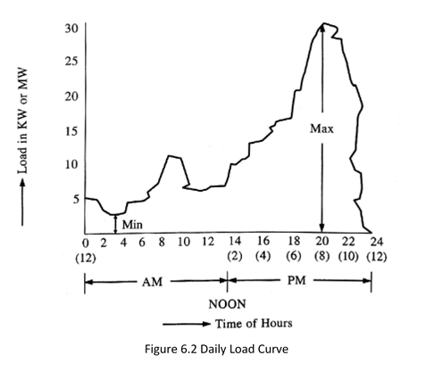

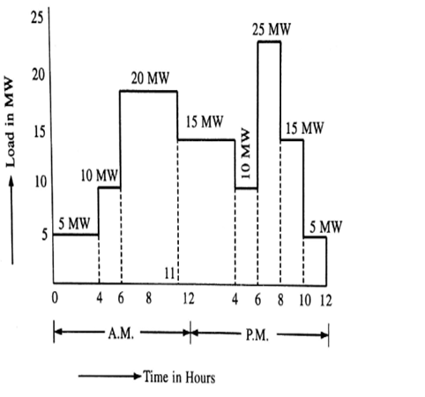
From the load curve we can know the following information.

- The variation in load during different hours of a day.
- The area under load curve represents the total number of units generated (in kWh) in a day.
- The maximum and minimum load in a day.
- The area under load curve (in kWh) divided by number of hours (24 hours) gives the average load on the power station.
Average load= Area under daily load curve( Kwh) / 24 hours
- The area under load curve divided by area of rectangle in which it is contained gives load factor.
- The Load curve helps in selecting the size and number of generating units.
- The load curve helps in preparing the operation schedule of the station.

LOAD DURATION CURVE

When the Load elements of a load curve are arranged in the order of descending magnitudes, the curve thus obtained is called a “Load Duration curve”.

- The Load Duration Curve is obtained from the same data as the Load Curve but the ordinates are arranged in the order of descending magnitudes.

- In other words, the maximum Load is represented to the left and decreasing loads are represented to the right in the descending order.

- Load Duration Curve gives the number of hours for which a particular load is on the Power station.

- The area under the Load duration curve is equal to that of the corresponding load curve. The area under this curve gives the number of units generated.

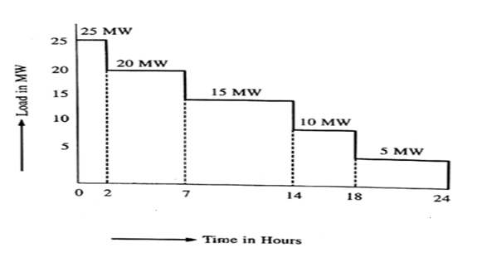
LOAD AND LOAD DURATION CURVE
Figure 6.3 Load Curve and Load duration curve

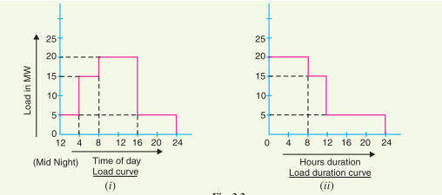

INTEGRATED LOAD DURATION CURVE (ENERGY LOAD DURATION CURVE)
This curve gives the total number of units generated (KWh) for the given demand.
Integrated load duration curve is drawn between the MW demand and the total energy generated (KWh or MWh) at a given demand.
In Integrated load duration curve on Y-axis, load demand in kW or MW is plotted while on x-axis corresponding number of units generated are obtained. Such a curve corresponding to load duration curve shown in Fig.

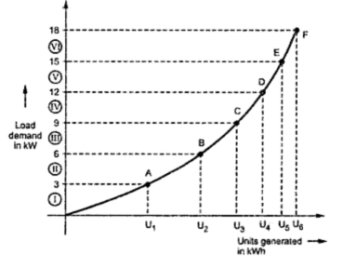
Fig. 1 Integrated Load Duration Curve

This curve is obtained from load duration curve. Let the load demand be 3 kW from the load duration curve in section I. The number of units generated corresponding to this demand will be area under section I which is shown as U₁ in integrated load duration curve. Similarly the other points are also obtained to get a total curve.
The number of units consumed by a load up to a particular time of a day can also be shown on a curve which is called as mass curve.
IMPORTANT TERMS AND FACTORS
CONNECTED LOAD: It is the sum of continuous ratings of all the equipments connected to supply system.
It is defined as the sum of the continuous ratings of all load-consuming apparatus connected to the system.
If a consumer has 5 incandescent lamps of 60 watt each and 2 fans of 80 watt each, then the total connected load
= 5 X 60 + 2 X 80
= 460 watt

MAXIMUM DEMAND (FOR PEAK LOAD)

The Maximum of all demands (loads) on a power station during a given period is known as Maximum Demand.
Generally all the consumers never switched on all the devices at full load simultaneously. If all consumers switched on simultaneously, then the load is equal to connected load.
Hence, Maximum Demand is always less than or equal to connected load. Maximum demand helps in determining the size and cost of the installation.

DEMAND FACTOR.
Demand factor is defined as the ratio of Maximum demand on the power station to the
connected load.

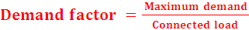

The value of demand factor is usually less than 1. It is expected because maximum demand on the power station is generally less than the connected load.
Demand factor is used to determine the capacity of the plant equipment.

AVERAGE LOAD.
The average of loads occurring on the power station in a given period (day or month or year) is known as average load or average demand.

LOAD FACTOR.
The ratio of average load to the maximum demand during a given period is known as load factor.
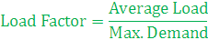

If the plant is in operation for T hours,




The load factor may be daily load factor, monthly load factor or annual load factor if the time period considered is a day or month or year.

Load factor is always less than 1 because average load is smaller than the maximum demand. The load factor plays key role in determining the overall cost per unit generated. Higher the load factor of the power station, lesser will be the cost per unit generated.

DIVERSITY FACTOR.
The ratio of the sum of individual maximum demands to the maximum demand on power station is known as diversity factor.

The sum of individual maximum demands is always greater than the maximum demand of the power station.
Hence, the diversity factor is always greater than unity (>1). The diversity factor reduces the capital cost of the station and rate of generation of electricity.

PLANT CAPACITY FACTOR.

It is the ratio of actual energy produced to the maximum possible energy that could have been produced during a given period i.e.,

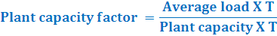

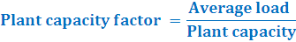

Thus if the considered period is one year,
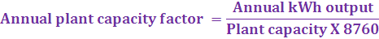

The plant capacity factor is an indication of the reserve capacity of the plant. A power station is so designed that it has some reserve capacity for meeting the increased load demand in future. Therefore, the installed capacity of the plant is always somewhat greater than the maximum demand on the plant.
Reserve capacity = Plant capacity - Max. demand

PLANT USE FACTOR.

It is ratio of kWh generated to the product of plant capacity and the number of hours for which the plant was in operation i.e.



Suppose a plant having installed capacity of 20 MW produces annual output of 7·35 × 10⁶ kWh and remains in operation for 2190 hours in a year. Then, Plant use factor =0·167 = 16·7%.

SELECTION OF GENERATING UNITS ( NUMBER AND SIZE OF GENERATING UNITS)

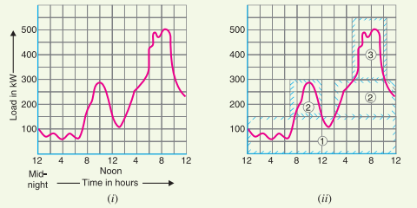
- The load on a power station is seldom constant; it varies from time to time. Obviously, a single generating unit (i.e., alternator) will not be an economical proposition to meet this varying load.

- It is because a single unit will have very poor efficiency during the periods of light loads on the power station. Therefore, in actual practice, a number of generating units of different sizes are installed in a power station.
- The selection of the number and sizes of the units is decided from the annual load curve of the station. The number and size of the units are selected in such a way that they correctly fit the station load curve.

Once this underlying principle is adhered to, it becomes possible to operate the generating units at or near the point of maximum efficiency.
Illustration. The principle of selection of number and sizes of generating units with the help of load curve is illustrated in Fig. The annual load curve of the station is shown in fig.It is clear from the curve that load on the station has wide variations; the minimum load being somewhat near 50 kW and maximum load reaching the value of 500 kW. It hardly needs any mention that use of a single unit to meet this varying load will be highly uneconomical.

As discussed earlier, the total plant capacity is divided into several generating units of different sizes to fit the load curve. This is illustrated in Fig. Here the plant capacity is divided into three units numbered as 1, 2 and 3. The cyan colour outline shows the units capacity being used. The three units employed have different capacities and are used according to the demand on the station. In this case, the operating schedule can be as under:

Time | Units in operation
From 12 midnight to 7 A.M. | Only unit no.1 is put in operation.
From 7 A.M. to 12.00 noon | Unit no. 2 is also started so that both units 1 and 2 are in operation.
From 12.00 noon to 2 P.M. | Unit no. 2 is stopped and only unit 1 operates.
From 2 P.M. to 5 P.M. | Unit no. 2 is again started. Now units 1 and 2 are in operation.
From 5 P.M. to 10.30 P.M. | Units 1, 2 and 3 are put in operation.
From 10. 30 P.M. to 12.00 midnight | Units 1 and 2 are put in operation.

Thus by selecting the proper number and sizes of units, the generating units can be made to operate near maximum efficiency. This results in the overall reduction in the cost of production of electrical energy.

Important Points in the Selection of Units

While making the selection of number and sizes of the generating units, the following points should be kept in view:
(i) The number and sizes of the units should be so selected that they approximately fit the annual load curve of the station.
(ii) The units should be preferably of different capacities to meet the load requirements. Although use of identical units (i.e., having same capacity) ensures saving in cost, they often do not meet the load requirement.
(iii) The capacity of the plant should be made 15% to 20% more than the maximum demand to meet the future load requirements.
(iv) There should be a spare generating unit so that repairs and overhauling of the working units can be carried out.
(v) The tendency to select a large number of units of smaller capacity in order to fit the load curve very accurately should be avoided. It is because the investment cost per kW of capacity increases as the size of the units decreases.

BASE LOAD AND PEAK LOAD ON POWER STATION

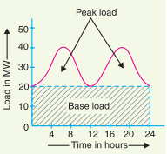
The changing load on the power station makes its load curve of variable nature. Fig shows the typical load curve of a power station. It is clear that load on the power station varies from time to time. However, a close look at the load curve reveals that load on the power station can be considered in two parts, namely;
(i) Base load
(ii) Peak load
(i) Base load.
The unvarying load which occurs almost the whole day on the station is known as base load.
Referring to the load curve of Fig it is clear that 20 MW of load has to be supplied by the station at all times of day and night i.e. throughout 24 hours. Therefore, 20 MW is the base load of the station. As base load on the station is almost of constant nature, therefore, it can be suitably supplied without facing the problems of variable load.
(ii) Peak load.
The various peak demands of load over and above the base load of the station is known as peak load.
Referring to the load curve of Fig it is clear that there are peak demands of load excluding base load. These peak demands of the station generally form a small part of the total load and may occur throughout the day.

Method of Meeting the Load

The total load on a power station consists of two parts viz., base load and peak load. In order to achieve overall economy, the best method to meet load is to interconnect two different power stations.
The more efficient plant is used to supply the base load and is known as base load power station. The less efficient plant is used to supply the peak loads and is known as peak load power station.
There is no hard and fast rule for selection of base load and peak load stations as it would depend upon the particular situation. For example, both hydro-electric and steam power stations are quite efficient and can be used as base load as well as peak load station to meet a particular load requirement.
Illustration. The interconnection of steam and hydro plants is a beautiful illustration to meet the load. When water is available in sufficient quantity as in summer and rainy season, the hydroelectric plant is used to carry the base load and the steam plant supplies the peak load.
However, when the water is not available in sufficient quantity as in winter, the steam plant carries the base load, whereas the hydro-electric plant carries the peak load as shown in fig.

ECONOMICS OF POWER GENERATION

The art of determining the per unit (i.e., one kWh) cost of production of electrical energy is known as economics of power generation.

(i) Interest.
The cost of use of money is known as interest.
A power station is constructed by investing a huge capital. This money is generally borrowed from banks or other financial institutions and the supply company has to pay the annual interest on this amount.
Therefore, while calculating the cost of production of electrical energy, the interest payable on the capital investment must be included. The rate of interest depends upon market position and other factors, and may vary from 4% to 8% per annum.
(ii) Depreciation.
The decrease in the value of the power plant equipment and building due to constant use is known as depreciation.
If the power station equipment were to last forever, then interest on the capital investment would have been the only charge to be made. However, in actual practice, every power station has a useful life ranging from fifty to sixty years.
From the time the power station is installed, its equipment steadily deteriorates due to wear and tear so that there is a gradual reduction in the value of the plant. This reduction in the value of plant every year is known as annual depreciation. Due to depreciation, the plant has to be replaced by the new one after its useful life. Therefore, suitable amount must be set aside every year so that by the time the plant retires, the collected amount by way of depreciation equals the cost of replacement.

COST OF ELECTRICAL ENERGY
The total cost of electrical energy generated can be divided into three parts, namely;

(i) Fixed cost; (ii) Semi-fixed cost; (iii) Running or operating cost.

(i) Fixed cost. It is the cost which is independent of maximum demand and number of units generated.
The fixed cost is due to
- the annual cost of central organisation,
- interest on capital cost of land
- salaries of high officials.
The annual expenditure on the central organisation and salaries of high officials is fixed since it has to be met whether the plant has high or low maximum demand or it generates less or more units. Further, the capital investment on the land is fixed and hence the amount of interest is also fixed.

(ii) Semi-fixed cost. It is the cost which depends upon maximum demand but is independent of units generated.
The semi-fixed cost is directly proportional to the maximum demand on power station
and is on account of
- annual interest and depreciation on capital investment of building and equipment,
- taxes,
- salaries of management and clerical staff.
The maximum demand on the power station determines its size and cost of installation. The greater the maximum demand on a power station, the greater is its size and cost of installation. Further, the taxes and clerical staff depend upon the size of the plant and hence upon maximum demand.

(iii) Running cost. It is the cost which depends only upon the number of units generated.
The running cost is on account of
- annual cost of fuel,
- lubricating oil,
- maintenance, repairs and
- salaries of operating staff.

Since these charges depend upon the energy output, the running cost is directly proportional to the number of units generated by the station. In other words, if the power station generates more units, it will have higher running cost and vice-versa.

Expressions for Cost of Electrical Energy
The overall annual cost of electrical energy generated by a power station can be expressed in two forms ie. three part form and two part form.

(i) Three part form. In this method, the overall annual cost of electrical energy generated is divided into three parts ie. fixed cost, semi-fixed cost and running cost
Total annual cost of energy = Fixed cost + Semi-fixed cost + Running cost
= Constant + Proportional to max. demand + Proportional to kWh generated.
=Rs (a + b kW + c kWh)
where
a = annual fixed cost independent of maximum demand and energy output. It is on account of the costs mentioned.

b = constant which when multiplied by maximum kW demand on the station gives the annual semi-fixed cost.
c = a constant which when multiplied by kWh output per annum gives the annual running cost.

(ii) Two part form. It is sometimes convenient to give the annual cost of energy in two part form. In this case, the annual cost of energy is divided into two parts i.e.
a fixed sum per kW of maximum demand plus a running charge per unit of energy.
The expression for the annual cost of energy then becomes:
Total annual cost of energy = Rs. (A kW + B kWh)
where A = a constant which when multiplied by maximum kW demand on the station gives the annual cost of the first part.
B = a constant which when multiplied by the annual kWh generated gives the annual running cost.
It is interesting to see here that two-part form is a simplification of three-part form.

TARIFF
The rate or charge at which electrical energy is supplied to a consumer is known as "Tariff".
The electric supplier produces electrical energy in a power station and is delivered to various consumers. These suppliers invest capital cost on equipment, land, building etc. and they derive income from consumers through electricity bills.
The different methods of charging consumers are known as Tariff. Tariff should be such that, it not only recovers the total cost of producing electrical energy, but also earns profit on the capital investment.

OBJECTIVES OF TARIFF
The main objective of Tariff is to recover various investments on production of electrical energy. Tariff should fulfill the following items.
• Recovery of cost of capital investment in generation, Transmission and distribution of equipment.
• Recovery of cost of operation, supplies, maintenance and losses.
• Recovery of cost of metering, billing collection and miscellaneous services.
• A satisfactory net returns on the capital investment.

FACTORS AFFECTING THE DESIGN OF TARIFF (OR)
BASIC CHARACTERISTICS OF TARIFF

The electric energy supply is different from other forms of business. Hence, the following factors will be taken into account while fixing the Tariff.
• It is not possible to store electricity in huge amounts. Hence, the tariff should be such that, it ensures proper returns from each consumer.
• Electrical energy must be available whenever needed. Hence, Tariff should earn sufficient money to meet the instant demand.
• The various consumers are encouraged to make effective and efficient use of electricity.
• The suppliers have a control up to the electricity meter. Hence, the use of electricity by consumer cannot be controlled.
• The Tariff should be designed in simple such that an ordinary consumer can easily understand it.
• The tariff should be fair in order to satisfy the different types of consumers.
• It should have a provision of charging a penalty for consumers at low power factor.
• The tariff should be uniform over large population.
• It should provide incentive for using electrical energy during off-peak hours.
• A big consumer should be charged at a lower rate than smaller consumer, because increase in use of electricity decreases the cost of generation per unit.

TYPES OF TARIFFS

Large number of Tariffs have been proposed time to time, but the following are some of the Tariffs which are in common use.
1. simple Tariff (or) Uniform Tariff
2. Flat Rate Tariff
3. Block Rate Tariff
4. Two-part Tariff
5. Maximum Demand Tariff
6. Power Factor Tariff

1. Simple Tariff (or) Uniform Tariff
If the rate or charge per unit of electrical energy consumed is fixed, such a tariff is known as Simple or Uniform Tariff.
This is the simplest type of tariff in which the cost of energy consumed is charged on the basis of number of units consumed. The cost per unit is charged as follows.
Advantages:
(a) It is simplest type of Tariff and easy to understand
(b) Calculation is easy.
Disadvantages:
(a) The cost per unit delivered will be higher.
(b) No discrimination between domestic (small) consumer and bulk consumers, hence all consumers have to pay equitably for the fixed charges.
(c) It does not encourage the use of electricity.
2. Flat Rate Tariff:
If the different types of consumers are charged at different rates per unit energy consumed, such a tariff is known as Flat rate Tariff.
In this type, the consumers are classified into different classes (such as domestic, industrial, public etc) and each class of consumer is charged at different rates. The different class of consumer is made by taking into account their load factors and diversity factors. If the consumer has two types of loads, say
(1) Lighting loads (light and fan etc) and
(2) Power loads,
then two meters are to be installed at his premises, one for lighting load and another for power load. The Flat rate per kWh (unit) for lighting load may be slightly higher than the power load. Suppose the rate per kWh for lighting load and power load be 60 paise and 55 paise and meter rent may be Rs.2.50/- per meter per month, then the monthly bill calculation will be as follows.

Type of Load | No. of units Consumed |  | Rate/Unit | Cost | Meter Rent |  | Total Bill
Lighting Load | Say 50 |  | 60 paise | 50 X 60=3000 paise  = Rs 30/- | Rs 2.50/- |  | Rs 32.50/-
Power | Say 80 |  | 55 paise | 80 X 55=4400 paise  = Rs 44/- | Rs 2.50/- |  | Rs 46.50/-
 |  | The total bill of a consumer per month Rs 79/-

Advantages:
(a) Tariff is fairer and it can be understood by different types of consumers.
(b) Simple in calculation.
Disadvantages:
(a) It is difficult to classify the consumers based on load factor and diversity factor.
(b) Separate meters are required for lighting and power load, will make the system complex and expensive.
(c) Does not encourage the use of electricity.

3. Block Rate Tariff:
If one block of energy is charged at a specified rate and next block of energy is charged at reduced rates, such a tariff is known as Block Rate Tariff.
In this type of tariff, the energy consumption is divided into blocks. The cost per unit in first block is high and the cost per unit in next blocks is progressively reduced. Hence, the consumer who consumes large units has to pay less as compared to the consumer, who consumes fewer units.
For example in a domestic the total number of units is 100, then
The first 30 units may be charged @ 60 paise per unit,
The next 50 units may be charged @ 50 paise per unit and
The remaining 20 units may be charged @ 30 paise per unit.
Then, the total bill will be 30x 60 + 50x 50 + 20x 30 = 4900 paise = Rs.49/-.

Advantages:
(a) The consumer gets an incentive for consuming more units.
(b) This tariff increases the load factor, thereby decreases the cost of unit generated.

Disadvantages:
(a) Dividing the units into blocks is problem.
(b) Calculating the bill.
4. Two-part Tariff:
If the consumers are charged on the basis of maximum demand and units consumed, such a tariff is knows as Two part Tariff.
In this type of Tariff, the total charges are split into two parts namely fixed charges and running charges. Fixed charges are proportional to maximum demand (kW) and running charges are proportional to number of units consumed (kWh).
Generally this tariff is expressed as
Total charges =Rs (a * kW + b * kWh)
Where a = Charge per KW of maximum demand
b = Charge per Kwh of energy consumed.
Advantages:
(a) It can be easily understand by the consumers.
(b) It recovers the fixed charges which depend on maximum demand, such as interest and depreciation on capital cost of building and equipment, taxes and insurance etc.
Disadvantages:
(a) The consumer has to pay his fixed charges, whether he has consumed electrical energy or not.
(b) There may be error in calculating the maximum demand of the consumer
5. Maximum Demand Tariff:
This Tariff is similar to two-part tariff except that, in this case the maximum demand is actually measured by using a maximum demand meter installed at the premises of the consumer.
If a consumer does not consume energy for a month the maximum demand meter reads zero, hence, the drawback of two-part tariff can be eliminated.
This tariff is mainly applicable to large industrial consumers, but not suitable for small consumer (domestic) as it requires a separate maximum demand meter.

6. Power Factor Tariff:
If the power factor of the consumer's load is taken into consideration such a tariff is known as power factor Tariff.
The efficiency of plant and equipment depends on power factor. Hence, in order to increase the utility of plant and equipment to maximum possible extent, the plant must be operated at a most economical power factor. So, the supplier has to encourage the consumer to operate the load at high power factor. The following are some types of power factor tariff.
kVA Maximum Demand Tariff: It is similar to two-part tariff except that the fixed charges are measured in KVA instead of KW. As KVA is inversely proportional to power factor, at high power factor the fixed charges will be less.
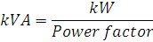
Hence, this tariff encourages the consumers to work at high power factor.
kWh and kVARh Tariff: In this type both kWh and KVARh supplied are charged separately. As kVARh is inversely proportional to power factor.
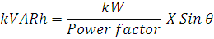
at high power factor the charge will be less. Hence, it is need to improve the power factor of a consumer load.
Sliding Scale or Average Power Factor Tariff: In this case an average power factor i.e. 0.8 lagging is taken as reference. If the power factor of the consumer is less than this value, additional charges are made and if the power factor is more than this value, a discount may be allowed. Hence, this results in improve the power factor of the consumer load.
2013
1. (a) Explain about characteristics and types of tariffs.
(b) The following two tariffs are offered
(i) Rs 100 plus 15 paise per unit
(ii) A flat rate of 30 paise per unit
At what consumption is first tariff is economical?
2. (a) Explain about choice of number and size of generation units.
(b) Calculate annual bill of a consumer whose maximum demand is 100kw, p.f=0.8 lagging
And load factor = 60%. The tariff used is Rs.75 per kvA of maximum demand plus 15
paise per kwh consumed.

2014

3. (a) write a short notes on load curve, load duration and integrated load duration curve.
(b) Define demand factor, Diversity factor, plant use factor.
4. (a) What do you understand by electrical tariff?
(b) Discuss two part tariff, three part tariff and power factor tariff.

2015
5. (a) Explain the following terms as applied to power system
(i) Diversity factor
(ii) Plant use factor
(iii) Demand factor.
(b)Write a short notes on integrated load duration curve.
6. (a) Name different types of tariffs, explain them briefly.
(b)Explain about cost of generation and their division into fixed, semi fixed and running
cost.

2016

7. (a) Explain Load curve and what are the information provided by this curve?
(b) A 1000 MW power station delivers 1000MW for 2 hours, 500MW for 6 hours and is
shut-down for the rest of each day. It is also shut-down for maintenance for 50 days
annually. Calculate its annual load factor.

8. (a)A Consumer needs one million units per year and his annual load factor is 50% . The tariff is
Rs 1,200/- per KW. Estimate the Saving in his energy cost, which would result if he improves
his load factor to 95%?
(b) Define load factor, utilization factor and Plant use factor?

